**A PROJECT PHASE-I REPORT**

**ON**

**OPTICAL PORT DATA COMMUNICATION USING DLMS COSEM**

SUBMITTED TO THE SAVITRIBAI PHULE PUNE UNIVERSITY, PUNE

IN THE PARTIAL FULFILLMENT FOR THE AWARD OF THE DEGREE

**OF**

**BACHELOR OF ENGINEERING**

**IN**

**ELECTRONICS AND TELECOMMUNICATION**

**BY**

## Nikhil Ekvachane Exam. No. 71820671B

**Soham Tembe Exam. No.** **71821587H**

**Sumeet Upasani Exam. No. 71821614J**

**UNDER THE GUIDANCE OF**

**PROF. P. G. CHILVERI**



**DEPARTMENT OF ELECTRONICS AND TELECOMMUNICATION ENGG**.

**STES’S**

**SMT. KASHIBAI NAVALE COLLEGE OF ENGINEERING**

**VADGAON BK., OFF.SINHGAD ROAD**

**PUNE 411041**

**2020– 2021**

**CERTIFICATE**

This is to certify that the project phase-I report entitled

“**OPTICAL PORT DATA COMMUNICATION USING DLMS COSEM**”

**Submitted by**

## Nikhil Ekvachane Exam. No. 71820671B

Soham Tembe Exam. No. 71821587H

Sumeet Upasani Exam. No. 71821614J

is a bonafide work carried out by them under the supervision of Prof. P. G. Chilveri and Prof. A.B. Chandgude it is approved for the partial fulfillment of the requirement of Savitribai Phule Pune University for the award of the Degree of Bachelor of Engineering (Electronics and Telecommunication Engineering)

This project Phase-I report has not been earlier submitted to any other Institute or University for the award of any degree or diploma.

Prof. A. B. Chandgude Prof. P.G. Chilveri

**Co-Guide Guide Department of E&TC Department of E&TC**

Prof. Dr. S.K. Jagtap Dr. A. V. Deshpande

**Head Principal**

**Department of E&TC S.K.N.C.O.E, Pune-41**

Place: Pune

Date:



\We are grateful to **Smt. Kashibai Navale College of Engineering, Pune** for giving us an opportunity to develop this project with an esteemed organization. The volume of the work would not have been possible without contribution in one form or the other by few names to mention.

We take this opportunity to acknowledge the support and continuous cooperation of all the people whose help was unparalleled importance in making this project a success. We welcome this opportunity to express our heartfelt gratitude and regards to our project guide **Prof. P. G. Chilveri** and our co-guide **Prof. A. B. Chandgude**, Department of Electronics and Telecommunication Engineering, Smt. Kashibai Navale College of Engineering, who encouraged and supported us by giving continuous guidance, which kept us motivated throughout the project.

We are thankful to our Honorable Principal, Smt. Kashibai Navale College of Engineering, Pune **Dr. A. V. Deshpande,** for the support.

We are highly grateful to **Dr. S. K. Jagtap**, Head of Department, Electronics and Telecommunication Engineering, Smt. Kashibai Navale College of Engineering for providing necessary facilities during the course of the work. We are thankful to and fortunate enough to get constant encouragement, support and guidance from all the Teaching staffs of Electronics and Telecommunication Department which helped us in successfully completing our project work. Also, we would like to extend our sincere esteems to all the staffs in laboratory for their timely support.

**Nikhil Ekvachane**

**Soham Tembe**

**Sumeet Upasani**

**ABSTRACT**

Energy meters are used for commercial purpose to record consumption of energy by consumer and correspondingly billing the consumer. Indian metering industry is a heterogeneous one with multiple communication protocols so even though there are many communication technologies used today for meter reading applications they lack the properties of interoperability and homogeneity. The presented solution describes a microcontroller-based device, which works on an Open Protocol, that provides real time local data display and record, for several electrical parameters, acquired from a power and energy meter device through optical communication. The open protocol used here is IEC 62056, which helps to overcome most of the challenges regarding data acquisition, uniformity and homogeneity among various energy meter manufacturers in India. This project focuses on DLMS COSEM Metering application protocol and provides guidelines on the implementation of DLMS COSEM in clients (data collection units) as well as in servers (Meters). The device is designed to be connected in a home, or residence, which makes it very useful as an interface for Optical Port Data Communication.

### CONTENTS

**CERTIFICATE** II

**ACKNOWLEDGEMENT** III

**ABSTRACT** IV

**CHAPTER TITLE PAGE NO.**

**1.** **INTRODUCTION 1**

* 1. BACKGROUND 1
  2. RELEVANCE 1
  3. PROBLEM STATEMENT 2

1.3.1 OBJECTIVES 2

**2.** **LITERATURE SURVEY 3**

* 1. INTRODUCTION 3
  2. REVIEW OF PREVIOUS RESEARCH WORK 3
  3. SUMMARY 5

**3. INTRODUCTION TO DLMS/COSEM 7**

3.1 INTRODUCTION 7

3.2 INFORMATION EXCHANGE IN DLMS/COSEM 8

3.3 THE COSEM INTERFACE CLASSES 9

3.4 COSEM OBJECT IDENTIFICATION SYSTEM (OBIS) 9

**4. DESIGN AND DRAWING 11**

4.1 SYSTEM BLOCK DIAGRAM 11

**5. SYSTEM REQUIREMENTS 12**

* + 1. 5.1 HARDWARE SPECIFICATIONS 12
    2. 5.2 SOFTWARE SPECIFICATIONS 12

**6. IMPLEMENTATION 13**

6.1 INTRODUCTION 13

* 2. **7. ADVANTAGES, DISADVANTAGES AND 14**

**APPLICATIONS**

7.1 ADVANTAGES 14

7.2 DISADVANTAGES 14

7.3 APPLICATIONS 14

**8. RESULTS AND DISCUSSION**

**9.** **CONCLUSIONS 15**

9.1 SCOPE FOR FUTURE ENHANCEMENTS 15

**10.**  **REFERENCES 16**

1. **INTRODUCTION**
   1. **BACKGROUND**

Energy meters are used for commercial purpose i.e. to record consumption of energy by consumer and correspondingly billing the consumer. In these days in every sector, there are number of customers which use the electricity but they are not satisfied with the services provided by power distribution companies. Electricity authority & the government realizes problems occurring in the existing transmission network, such as increasing cost due to poor operational efficiency, environmental impacts and an ongoing demand for energy. The idea of remote metering was born in the 1960s. Initially, remote pulse transmission was used, but this has gradually been replaced by using various protocols and communication media. Today’s energy meters are data loggers. Now-a-days, meters with complex functionality are based on the latest electronic technology, using digital signal processing, with most functions being implemented in firmware. They give much more than just energy readings. Meters have a large amount of data, which is not practical to read using the given display and can be better read electronically.

* 1. **RELEVANCE**

One of the major components of operational cost in an electrical utility system is the cost of acquiring data on consumption of the thousands of consumers, spread over a large geographical area, connected to the system. Typically, acquiring data on energy consumption is accomplished by making a meter reader visit the premises of each and every consumer and record data manually. Time and again loss of revenue to the utility occurs because of human errors in acquiring data on the consumption of individual consumers. Automating the entire process of acquiring data and billing will reduce the cost by eliminating human intervention in meter reading. The task of collecting data on electricity consumption without human intervention is popularly known as automatic meter reading (AMR). To facilitate automatic data collection, the metering systems should be networked. The earlier Common Meter Reader Instrument (CMRI) had a hardware/ software that used different communication protocols as provided by various manufacturers to download data from the meters of respective manufacturers, all of which were generally supplied with their own data exchange formats or protocols. To ensure interoperability of energy meters, implementing open protocol was the only true solution. Today for Indian power sector “IEC 62056 Electricity metering – Data exchange for meter reading, tariff and load control” (DLMS COSEM) is adopted for implementation in meters as the open protocol for meter data exchange. This series of IEC standards are supported by the Indian Companion Specification as IS 15959. This project aims to enhance the homogeneity in different makes of meters by developing a common meter reading instrument that follows DLMS COSEM protocol and reads any meter data accurately and efficiently.

* 1. **PROBLEM STATEMENT**

To Implement optical port data communication on any microcontroller as per IS 15959 which serves on DLMS COSEM protocol.

* + 1. **OBJECTIVES**
* To study DLMS COSEM object model.
* To study IS 15959 of the DLMS COSEM protocol.
* To design a client for a typical energy meter.
* To develop a reader using Arduino with optical port.
* To develop a method for establishing association between the client and the server to communicate data optically.

1. **LITERATURE SURVEY**

* 1. **INTRODUCTION**

This main concept of this project revolves around an Open Protocol called DLMS/COSEM which is used here for the purpose of data exchange. The DLMS/COSEM specification specifies an interface model and communication protocols for data exchange with metering equipment. DLSMS/COSEM Open Protocol follows a client/server model where data collection systems play the role of the client and metering devices play the role of the server. For communication to the server many options are available as wired or wireless such as, power lines, cable networks, RF modules, GSM modules, Zigbee, which are studied by different researchers. Different approaches were used by the researchers to simplify the meter reading process and increase the overall efficiency of the process.

* 1. **REVIEW OF PREVIOUS RESEARCH WORK**

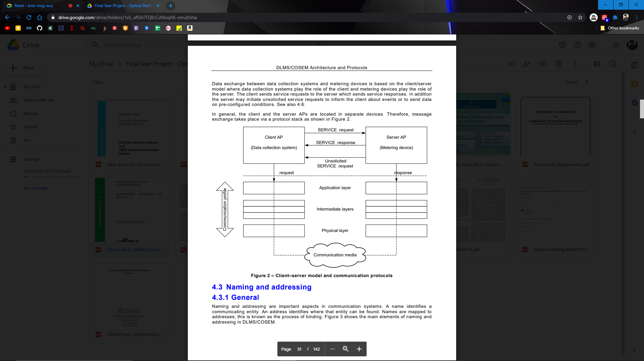DLMS/COSEM User Association formulates and maintains the documentation of world-wide established standards of DLMS/COSEM. The Green Book Edition 9 [1] describes the complete technical information about the DLMS/COSEM protocol. The DLMS/COSEM specification specifies an interface model and communication protocols for data exchange with metering equipment. The objective of DLMS/COSEM is to specify a standard for a business domain-oriented interface object model for metering devices and systems, as well as services to access the objects. This Technical report, the “Green Book” specifies the DLMS/COSEM application layer, lower protocol layers and communication profiles. DLMS/COSEM uses the concepts of the Open Systems Interconnection (OSI) model to model information exchange between meters and data collection systems. Data exchange between data collection systems and metering devices is based on the client/server model where data collection systems play the role of the client and metering devices play the role of the server. The client sends service requests to the server which sends service responses. In addition, the server may initiate unsolicited service requests to inform the client about events or to send data on pre-configured conditions.

1. Fig. 1 Client-server model and communication protocols

Blue Book Edition 12.2[2] guide describes the basic principles on which the COSEM interface classes (ICs) are built. It also gives a short overview on how interface objects – instantiations of the ICs – are used for communication purposes. Data collection systems and metering equipment from different vendors, following these specifications, can exchange data in an interoperable way. In order to access COSEM objects in the server, an application association (AA) shall first be established with a client. AAs identify the partners and characterize the context within which the associated applications will communicate. OBIS provides a unique identifier for all data within the metering equipment, including not only measurement values, but also abstract values used for configuration or obtaining information about the behavior of the metering equipment. The ID codes defined in this document are used for the identification of:

1. logical names of the instances of the Interface Classes, the objects
2. data transmitted through communication lines
3. data displayed on the metering equipment

A technical document issued by Bureau of Indian Standards [3] provides a suitable approach to the implementation of the IEC-62056 standards and this Indian Companion Specification in such devices. For each logical device the DLMS/COSEM server shall support one association with properties, objects, and access rights adequate for transferring the stored data of the corresponding meter to the BCS in an efficient manner. The server within the HHU is not required to support ad-hoc access or selective access to the data that differs from the requests which were earlier used to read the data from the meter. HHUs (Hand Held Units also called CMRI or MRI) may retrieve data from DLMS/COSEM Meters conforming to this standard using the communication ports. HHUs shall provide a DLMS/COSEM server interface to the BCS (Base Computer System — the Data collection software) over a suitable communication medium. We learn more about the CMRI and its functions through another technical report issued by Central Electricity Authority [4] which states CMRI supports two modes of operation: CLIENT_MODE and SERVER_MODE. In CLIENT_MODE, CMRI reads and displays selectively or all the instantaneous values, Energy values and demand values, etc., that are specified in ICS. CMRI downloads data from the various meters. CMRI also uploads programmable parameters for desired meters. In SERVER_MODE, CMRI uploads to BCS all the downloaded data from various meters.

Pradish M. et. al has defined in his technical report [5] the important characteristic of DLMS/COSEM i.e.Interoperability. Interoperability could be defined as “The ability of a system or a product to work with other systems or products without special effort on the part of the customer”. Any system can read any meter and no special involvement of vendors. The report [5] also describes that the choice of communication medium is equally important as it along with protocol which assures seamless connectivity in the chosen distribution network and ensure successful implementation of the application. The application software at either end aided by a common open protocol can exchange required information as and when needed protocol which assures seamless connectivity in the chosen distribution network and ensure successful implementation of the application. On the same grounds, the paper by Gordon Struklec et. al [6] adds that DLMS/COSEM covers all the AMR/AMI application fields and supports all the communication media (except maybe wireless mesh networks). The lack of the PC client application which includes all (or most of) DLMS features and which is able to interpret data in a user-friendly way makes the integration process more difficult and more time-consuming. Main function of an Automatic Meter Reading (AMR) system is gathering meter data for billing in an automated way. Various standard-based techniques enable local or remote connections to meters, e.g. IEC62056-21, IEC62056-31, M-bus, GSM, GPRS, PSTN, Internet, PLC. As stated here, for our project we are using IEC62056-21 which is also known as the DLMS/COSEM Protocol.

While reviewing the previous research work on the topic of our project, it was found that different approaches were opted by the researches to implement different models realized using same protocol and concept but different methodology and components were used for different applications.

Subrata Biswas et. al. in her paper [7] described a PC based Energy meter billing system for home and commercial buildings. She explains how the PC based energy meter monitoring system can gather data for remote reporting. Radio frequency used in this PC based power monitoring system can take many forms. The more common ones are handheld, mobile, satellite and fixed network solutions. The software used for her model is written in C-sharp because C# language is intended to be a simple, modern, general-purpose, object-oriented programming language and it can be modified.

Hiren R. Zala et. al. proposed in his paper [8] an Energy Meter Data Acquisition System with Wireless Communication for Smart Metering Application in which he used an effective technology of MSP430G microcontroller and CC2500 RF transceiver that saves the power very much. The message collection of the meter readings at the utility office is done with the use of one SIM300 based GSM module same used in the center node and data collector software Ozeking. The drawback of this system is that a GSM module has to be connected with each Energy meter which will increase the overall cost of the system.

Whereas F. Dragan et. Al describes another approach in his paper [9] where he proposed a Local Monitoring / Recording and Display Device for Power Electricity Meter, using IEC 62056–21 which is a Local AMR application device for DLMS-COSEM based Power Meters. In this model, the RS232 serial interface is used to connect the device with the power meter using an appropriate physical layer communication protocol, like IEC 62056-21. Parameters are identified using short OBIS codes, each value being followed by its measure unit. A simple message exchange consists of pairs of “queries”, “acknowledgements” and “responses”.

* 1. **SUMMARY**

After review of the established standards and previous research work, we understand the advantages and disadvantages of various approaches used by the researchers. We also understand the established standard of DLMS/COSEM Open protocol and how to implement our project using the protocol.

|  |  |  |
| --- | --- | --- |
| Paper | Author | Key Points |
| [4] “Functional requirements for Common Meter Reading Instrument”, December 2011. | Central Electricity Authority, Central Power Research Institute | * CMRI supports two modes of operation: CLIENT_MODE and SERVER_MODE. * In CLIENT_MODE, CMRI reads and displays selectively or all the instantaneous values, Energy values and demand values, etc., that are specified in ICS. * In SERVER_MODE, CMRI uploads to BCS all the downloaded data from various meters. |
| [5] “Testing energy meter compliance for protocol and performance as per standards”, Central Power Research Institute, Bangalore. | Pradish. M,  V. Arunachalam,  V. Shivakumar,  Mridula Jain | * The choice of communication medium is equally important as it along with protocol which assures seamless connectivity in the chosen distribution network and ensure successful implementation of the application. * Interoperability could be defined as “The ability of a system or a product to work with other systems or products without special effort on the part of the customer”   – Any system can read any meter  – No special involvement of vendors |
| [6]” Implementing DLMS/COSEM in Smart Meters”, 8th International Conference on the European Energy Market (EEM), 25-27 May 2011 | Gordan Štruklec,  Joško Marši | * The lack of the PC client application which includes all (or most of) DLMS features and which is able to interpret data in a user-friendly way makes the integration process more difficult and more time-consuming. * Various standard-based techniques enable local or remote connections to meters, e.g. IEC62056-21, IEC62056-31, M-bus, GSM, GPRS, PSTN, Internet, PLC. |
| [7] “PC Based Low-Cost Energy Meter Billing System for Home and Commercial Buildings” International Journal of Scientific & Engineering Research, Volume 5, Issue 2, February-2014 | Subrata Biswas, Mubinul Haque, Arafat Kabir, Md. Iftekhar Alam,  Avijeet Banik, | * Radio frequency used in this PC based power monitoring system can take many forms. The more common ones are handheld, mobile, satellite and fixed network solutions * The software is written in C-sharp because C# language is intended to be a simple, modern, general-purpose, object-oriented programming language and it can be modified. |
| [8]” Energy Meter Data Acquisition System with Wireless Communication for Smart Metering Application” International Journal of Engineering Research & Technology (IJERT), Vol. 3 Issue 11, November-2014 | Hiren R. Zala,  Viranchi C. Pandya | * A GSM module has to be connected with each Energy meter which will increase the overall cost of the system. * The most effective technology of MSP430G microcontroller and CC2500 RF transceiver save the power very much. * The message collection of the meter readings at the utility office is done with the use of one SIM300 based GSM module same used in the center node and data collector software Ozeking |
| [9] “Local Monitoring / Recording and Display Device for Power Electricity Meter, using IEC 62056–21 Local AMR application device, hardware solution, for DLMS-COSEM based Power Meters," 2019 8th International Conference on Modern Power Systems (MPS), Cluj Napoca, Romania, 2019 | F. Drăgan,  R. Holonec,  R. Copîndean | * The RS232 serial interface is used to connect the device with the power meter using an appropriate physical layer communication protocol, like IEC 62056-21. * Parameters are identified using short OBIS codes, each value being followed by its measure unit. |

1. **INTRODUCTION TO DLMS/COSEM**
   1. **INTRODUCTION**

The DLMS/COSEM specification specifies an interface model and communication protocols for data exchange with metering equipment. The interface model provides a view of the functionality of the meter as it is available at its interface(s). It uses generic building blocks to model this functionality.

The DLMS/COSEM specification follows a three-step approach.

Step 1, Modelling: This covers the interface model of metering equipment and rules for data

Identification.

Step 2, Messaging: This covers the services for mapping the interface model to protocol data units (APDU) and the encoding of this APDUs.

Step 3, Transporting: This covers the transportation of the messages through the communication channel.

DLMS/COSEM provides built-in security mechanisms from the outset. Initially, it provided mechanisms for the identification and authentication of clients and servers, as well as specific access rights to COSEM object attributes and methods within application associations (AAs) established between a client and a server. Ciphered APDUs were also available to allow protecting the messages exchanged between clients and servers.

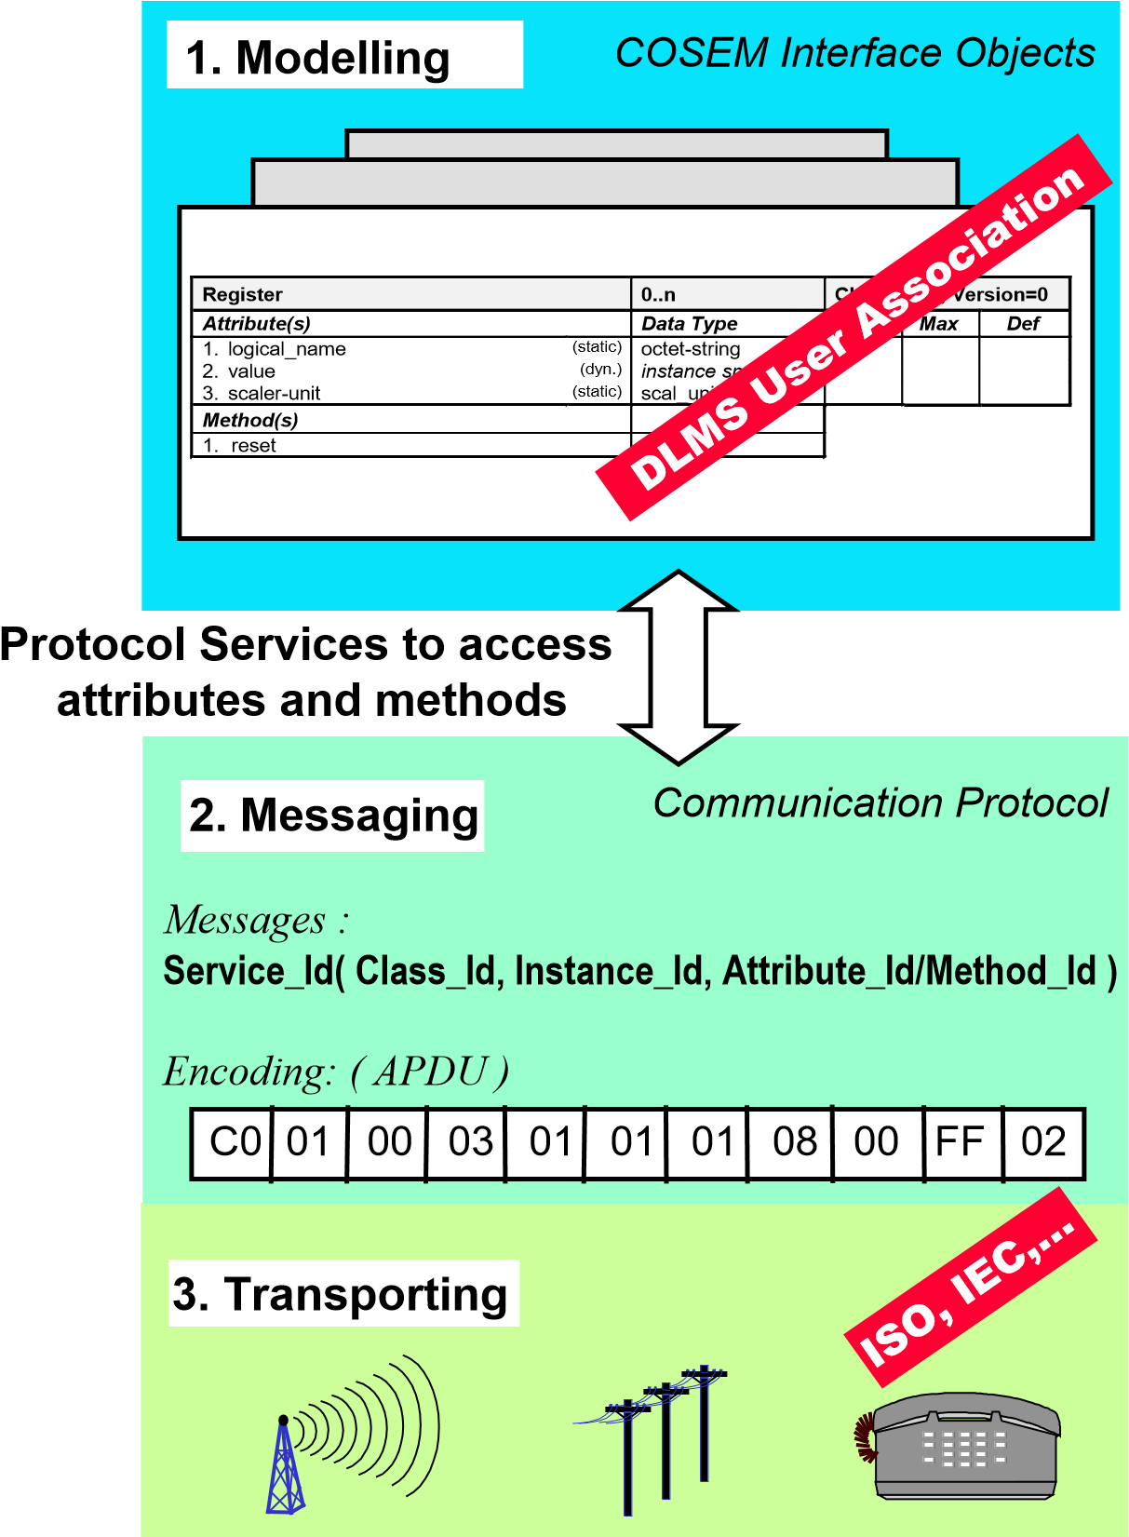

* 1. **INFORMATION EXCHANGE IN DLMS/COSEM**

The objective of DLMS/COSEM is to specify a standard for a business domain-oriented interface object model for metering devices and systems, as well as services to access the objects. Communication profiles to transport the messages through various communication media are also specified. The term "metering devices" is an abstraction; consequently “metering device” may be any type of device for which this abstraction is suitable.

The key characteristics of data exchange using DLMS/COSEM are the following:

* metering devices can be accessed by various parties: clients and third parties;
* mechanisms to control access to the resources of the metering device are provided; these mechanisms are made available by the DLMS/COSEM AL and the COSEM objects (“Association SN / LN” object, “Security setup” object);
* security and privacy is ensured by applying cryptographical protection to xDLMS messages and to COSEM data;
* low overhead and efficiency is ensured by various mechanisms including selective access, compact encoding and compression;
* at a metering site, there may be single or multiple metering devices. In the case of multiple metering devices at a metering site, a single access point can be made available;
* data exchange may take place either remotely or locally. Depending on the capabilities of the metering device, local and remote data exchange may be performed simultaneously without interfering with each other;
* various communication media can be used on local networks (LN), neighborhood networks (NN) and wide area networks (WAN).

The key element to ensure that the above requirements are met is the Application Association (AA) – determining the contexts of the data exchange – provided by the DLMS/COSEM AL. DLMS/COSEM uses the concepts of the Open Systems Interconnection (OSI) model to model information exchange between meters and data collection systems. Data exchange between data collection systems and metering devices is based on the client/server model where data collection systems play the role of the client and metering devices play the role of the server. The client sends service requests to the server which sends service responses. In addition, the server may initiate unsolicited service requests to inform the client about events or to send data on pre-configured conditions. In general, the client and the server APs are located in separate devices. Therefore, message exchange takes place via a protocol stack

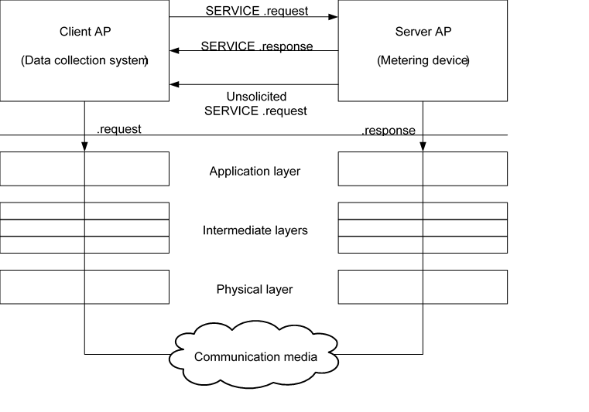

* 1. **THE COSEM INTERFACE CLASSES**

Data collection systems and metering equipment from different vendors, following these specifications, can exchange data in an interoperable way.



*class identifier Attributes Instantiation*

g

**Total Positive Active Energy: Register**

logical_name = [1 1 1 8 0 255]

value = 1483

…

**Total Positive Reactive Energy: Register**

logical_name = [1 1 3 8 0 255]

value = 57

…

reset

logical_name: octet-strin value: instance specific

...

**Register** class_id=3

* 1. **COSEM OBJECT IDENTIFICATION SYSTEM (OBIS)**

The Object Identification System (OBIS) defines the identification codes for commonly used data items in metering equipment. OBIS provides a unique identifier for all data within the metering equipment, including not only measurement values, but also abstract values used for configuration or obtaining information about the behaviour of the metering equipment. The ID codes defined in this document are used for the identification of:

* + logical names of the instances of the ICs, the objects.
  + data transmitted through communication lines.
  + data displayed on the metering equipment.

This applies to all types of metering equipment, such as fully integrated meters, modular meters, tariff attachments, data concentrators etc.

**OBIS code structure**

**Value groups and their use**

|  |  |
| --- | --- |
| Value group | Use of the value group |
| A | Identifies the media (energy type) to which the metering is related. Non-media related information is handled as abstract data. |
| B | Generally, identifies the measurement channel number, i.e., the number of the input of a metering equipment having several inputs for the measurement of energy of the same or different types (for  example in data concentrators, registration units). Data from different sources can thus be identified. It may also identify the communication channel, and in some cases, it may identify other elements.  The definitions for this value group are independent from the value group A. |
| C | Identifies abstract or physical data items related to the information source concerned, for example  current, voltage, power, volume, temperature. The definitions depend on the value in the value group A.  Further processing, classification and storage methods are defined by value groups D, E and F.  For abstract data, value groups D to F provide further classification of data identified by value groups A to C. |
| D | Identifies types, or the result of the processing of physical quantities identified by values in value groups A and C, according to various specific algorithms. The algorithms can deliver energy and demand quantities as well as other physical quantities. |
| E | Identifies further processing or classification of quantities identified by values in value groups A to D. |
| F | Identifies historical values of data, identified by values in value groups A to E, according to different billing periods. Where this is not relevant, this value group can be used for further classification. |

1. **DESIGN AND DESCRIPTION**
   1. 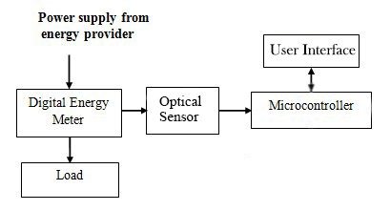**SYSTEM BLOCK DIAGRAM**

Fig. 2 Block Diagram of Optical Port Data Communication using DLMS/COSEM

The above block diagram describes the system that we are introducing in this project. This system broadly consists of a meter which acts as a server while the reader device acts as the client. As described in the block diagram, the Digital Energy Meter acts as an interface between the user and the power supply from the energy provider. The Reader device consists of an Optical sensor, a microcontroller and a user interface (Laptop/PC). Let’s understand their functions as following:

##### Optical Sensor

Common Optical Probe with Optical band width 900 to 1000 Nano meters is used here whose optical eye is connected to the meter and the USB end is connected to the Microcontroller. The Optical sensor acts as a communication channel between Meter and Reader. Its main function is to collect data through the Optical port present on the Energy Meter.

##### Microcontroller

Microcontroller acts as the heart of our project. Here we are using Arduino Uno (ATMEGA 328P) as our microcontroller. It establishes an association between the server (Energy Meter) and the Client (Reader). The main function of the microcontroller unit is to interpret the data received from the meter.

##### User Interface (Laptop/PC)

This unit acts as the user interface between the user and the Reader device. It displays the data acquired from the meter for better understanding and acts as a terminal to send commands to communicate with the Server (Energy Meter). For this project, we use Laptop as the User Interface which is connected with the Microcontroller unit.

According to the proposed methodology, we put together a reader device using Arduino Uno (ATMEGA 328P) and connecting it to the Energy Meter through the Optical probe. With the help of the terminal displayed on the User Interface, we establish an association with the Energy meter after successfully completing a process called “Hand-shake”. Later on, we communicate with the Energy Meter and acquire data from it in the form of electrical parameters which is made visible on the User Interface Display.

1. **SYSTEM REQUIREMENTS**
   1. **HARDWARE SPECIFICATION**
   2. Micro-controller – Arduino Uno (ATMEGA 328P)
   3. Common Optical Probe with Optical band width 900 to 1000 Nano meters
   4. User Interface- Laptop/PC
   5. **SOFTWARE SPECIFICATION**
   6. Visual Studio Code
   7. Python 3.7
      1. Python is a general-purpose object-oriented programming language with high-level programming capabilities. It has become famous because of its apparent and easily understandable syntax, portability and easy to learn. Python is a programming language that includes features of C and Java. It provides the style of writing an elegant code like C, and for object-oriented programming, it offers classes and objects like Java.
      2. Python is derived from programming languages such as ABC, Modula 3, small talk, Algol-68.
      3. Python page is a file with a .py extension that contains could be the combination of HTML Tags and Python scripts.
   8. Arduino IDE 1.8.13
2. **IMPLEMENTATION**

**6.1 INTRODUCTION**

Our project consists of an L&T Meter with a L&T specific Optical cable used to transmit data between the meter and an Arduino Uno. The first part of the implementation process requires us to complete the Handshake with the meter. A Handshake as per the DLMS COSEM protocol refers to the authentication necessary to be completed before the further process initiated. For the authentication purposes we connected the cable directly to the laptop in order to achieve results in a convenient way. The L&T Optical cable requires certain drivers which were installed on the laptop to attain the connection response. The optical cable then acts as serial port cable which can then be u connected to the meter on the respective slot provided.

Our project also includes the use of Arduino Uno with the Atmega Microcontroller. This particular board and microcontroller are chosen because of fair advantages of using it over other boards.

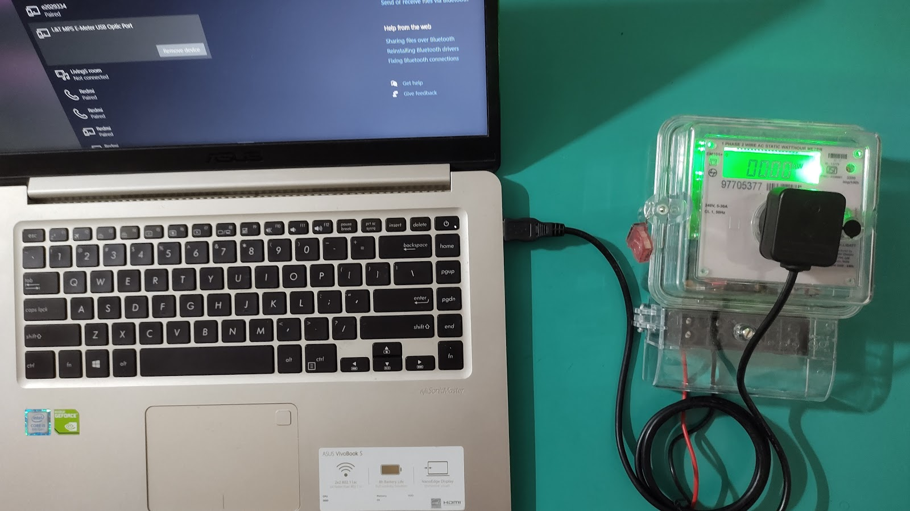

**7. ADVANTAGES, DISADVANTAGES AND APPLICATIONS**

**6.1 ADVANTAGES**

* 1. Data is read electronically. Hence, human errors eliminated.
  2. Can read meters by different manufacturers accurately.
  3. Capable to communicate with static energy meters or computers.
  4. Interoperability is brought about by the implementation of DLMS COSEM.

**6.2 DISADVANTAGES**

1. Cannot eliminate the need of human involvement.
2. Base Computer Software (BCS) are needed for data interpretation of complex electrical parameters.

**6.3 APPLICATIONS**

1. Used for data reading from various makes of meters.

**9. CONCLUSION**

There are many communication technologies used today for meter reading applications, but lack the properties of interoperability and homogeneity. Device described in this project is a solution for meter reading system with capabilities of local display of electrical parameters. In advancement, wireless modules can be used along with other technologies and result can be further improved.

**9.1 SCOPE FOR FUTURE ENHANCEMENTS**

Creating a smart meter architecture minimizes human intervention in metering, billing and collection process and helps in reducing theft by identifying loss pockets. It requires a two-way communication network, control center equipment and software applications that enable near real-time gathering and transfer of energy usage information. India is aiming to replace the present-day digital meters with the smart meters in near future. In terms of future enhancements, the Reader device introduced in our project will act as an important intermediate block which will simplify the process of bridging the present model of digital meters to the aimed smart meters without incurring heavy losses as well as cutting down the expanses of replacing and discarding the old digital meter. Our reader device basically turns the present-day digital meters to be compatible with the aimed Smart meters.

**10.** **REFERENCES**

1. Excerpt – “DLMS/COSEM Architecture and Protocols”, Edition 9, DLMS User Association, May 2019
2. Excerpt – “COSEM Interface Classes and OBIS Object Identification System”, Edition 12.2, DLMS User Association, January 2017
3. “DATA EXCHANGE FOR ELECTRICITY METER READING, TARIFF AND LOAD CONTROL COMPANION SPECIFICATION”, April 2011, Bureau of Indian Standards
4. “Functional Requirements for Common Meter Reading Instrument” by Central Electricity Authority and Central Power Research Institute, December 2011
5. Pradish. M, V. Arunachalam, V. Shivakumar, Mridula Jain, “Testing energy meter compliance for protocol and performance as per standards”, Central Power Research Institute, Bangalore.
6. Gordon Struklec, Josko Marsi,” Implementing DLMS/COSEM in Smart Meters”, 8th International Conference on the European Energy Market (EEM), 25-27 May 2011
7. Subrata Biswas, Mubinul Haque, Arafat Kabir, Md. Iftekhar Alam, Avijeet Banik, “PC Based Low-Cost Energy Meter Billing System for Home and Commercial Buildings” International Journal of Scientific & Engineering Research, Volume 5, Issue 2, February-2014
8. Hiren R. Zala, Viranchi C. Pandya,” Energy Meter Data Acquisition System with Wireless Communication for Smart Metering Application” International Journal of Engineering Research & Technology (IJERT), Vol. 3 Issue 11, November-2014
9. F. Drăgan, R. Holonec and R. Copîndean, "Local Monitoring / Recording and Display Device for Power Electricity Meter, using IEC 62056–21 Local AMR application device, hardware solution, for DLMS-COSEM based Power Meters," 2019 8th International Conference on Modern Power Systems (MPS), Cluj Napoca, Romania, 2019